**LAB REPORT - Installing MySQL**

Course Code - Course Name: - COMP4041 - Operating System

Program: T433 - Cybersecurity

Term: - Winter 2024

Lab Number - Topic: Lab 5 - Installing MySQL

Student Name - ID: Prabhjot Singh Sains – 101495218

1. **Create a screenshot of your MySQL Workbench or another client that can successfully connect to your MySQL server running on your VM via your host operating system.**

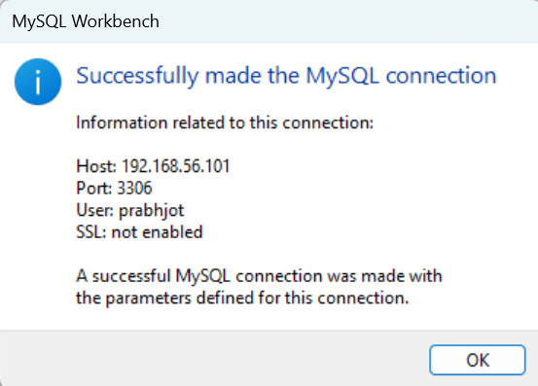

1. **The command to back up entire MySQL Databases to a file that can later be imported into other systems’ MySQL servers:**

mysqldump -u root -p --all-databases > all_databases_prabhjot.sql;



1. **The command to restore the backup to the current MySQL server:**

mysql -u root -p < all_databases_prabhjot.sql

To explain this, I have created a database named db_test. After creating the table I backed up all the database using the mysqldump command. After this, I dropped the db_test database and entered the command to back up all the databases.

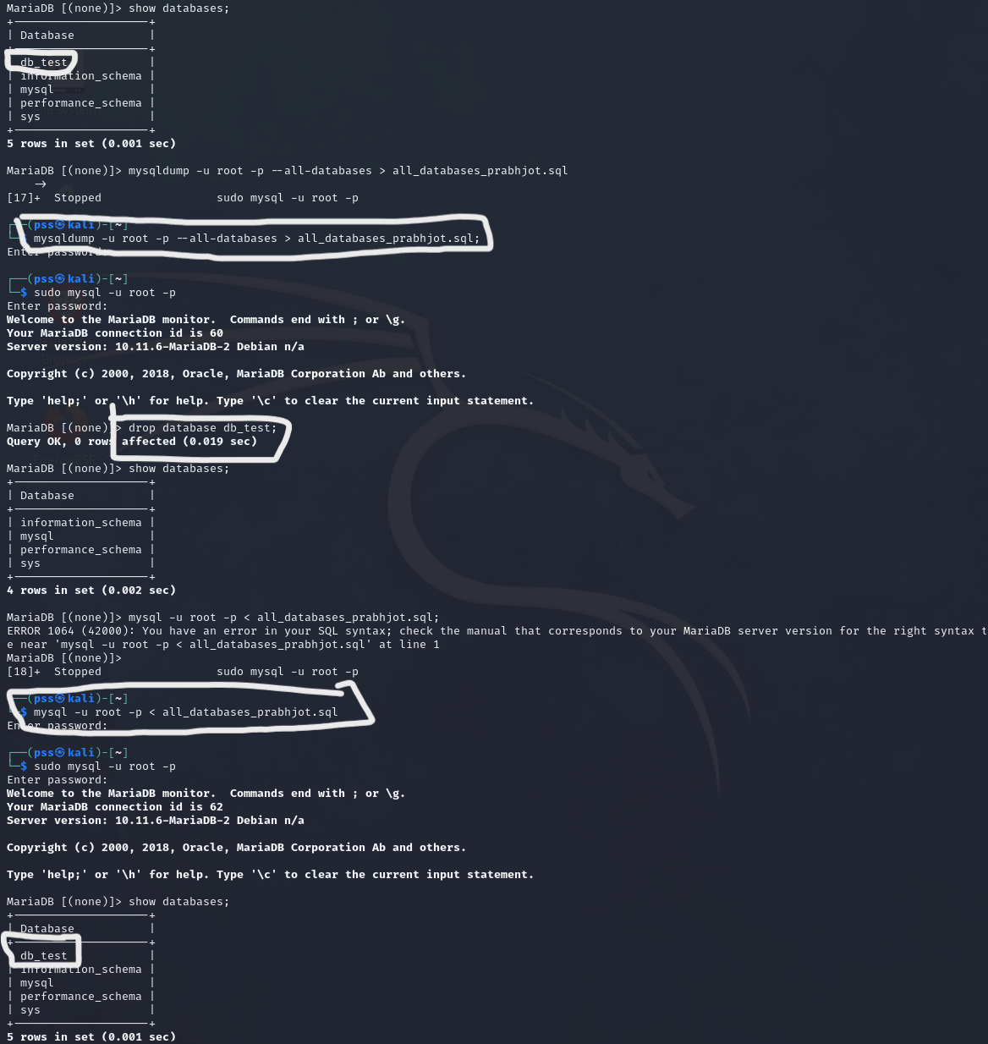

1. **The command to only backup the specific database that was created for remote user:**

mysqldump -u prabhjot -p'prabhjot' db_prabhjot > db_prabhjot_backup.sql;

